# CS 255 System Design Document

This template lays out all the different sections that you need to complete for Project Two. Each section has guidance to prompt your thinking. You will need to continually reference the interview transcript as you work to make sure that you are addressing your client’s needs. There is no required length for the final document. Instead the goal is to complete each section based on what your client’s needs are. Remove this note when you are finished, and replace all bracketed text with the relevant information.

## UML Diagrams

### UML Use Case Diagram

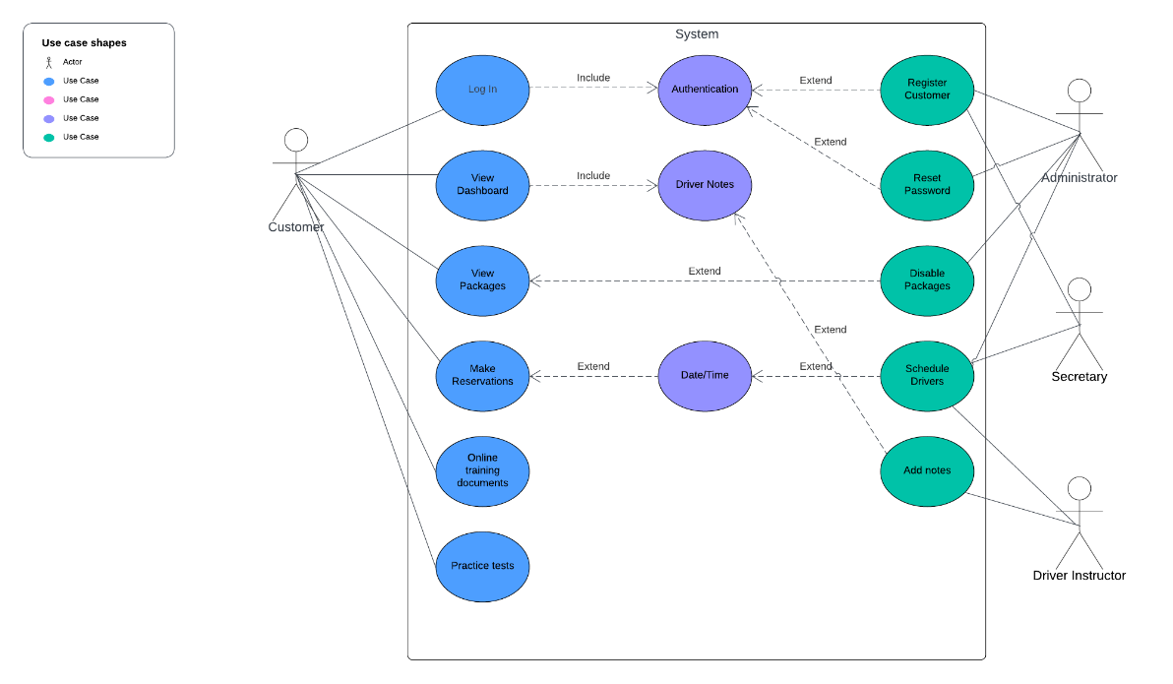

### UML Activity Diagrams

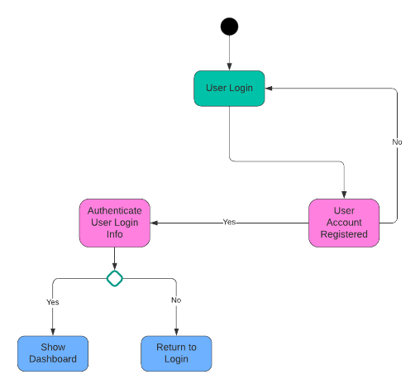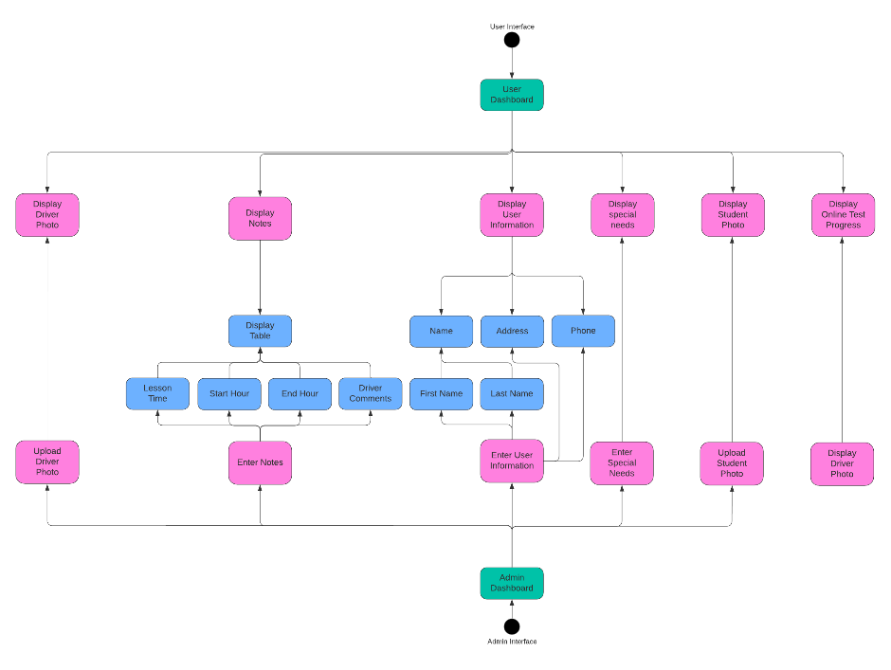

### UML Sequence Diagram

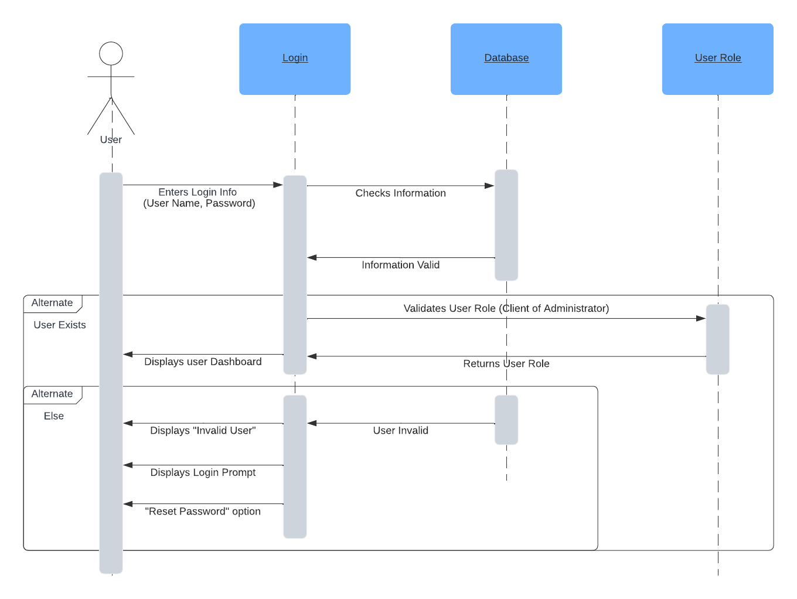

### UML Class Diagram

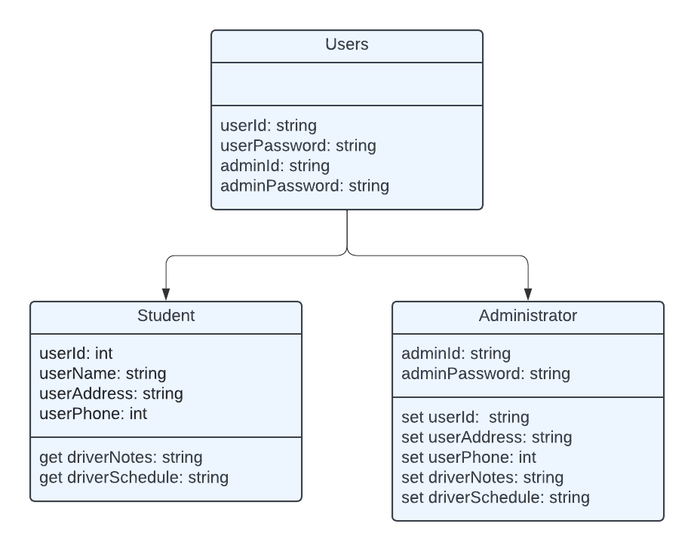

## Technical Requirements

Since this will be a web-based system I personally would go about utilizing a Linux-based server with Apache2 web applications. We will need to run an SQL database set-up and an html protocol with Javascript. These are all systems that I’m familiar with and have used. If I were to design this system today, these are the basic software components that I would utilize. Encrypting the system with no less than 256 bit encryption to protect our information with an additional encryption code on the database for further security on the client information. The number of servers needed will depend on the active traffic on the system. If I were to build this system at the clients location, then the client would need to employ an internet connection capable of the amount of active traffic, a modem with a firewall and proper configuration for remote administrative access, and a router/switch with a similarly constructed firewall. The firewall will only allow incoming access from certain IP addresses with encryption keys stored on both systems. This will allow only those administrators that will be servicing the system to access the server remotely, which will further protect user information from theft. Although, I would not personally recommend for this to be available. I would recommend only having server access from the physical server portal, that way there is no open incoming port on the hardware which makes theft even more difficult.

Rather using a Linux system or a Windows system, the underlying software components will be very similar. The firewalls, and databases will be constructed similarly. And the physical hardware will be identical.